Fast**National University of Computer & Emerging Sciences, Karachi  
Fall-2018 CS-Department**

**Lab Mid**

|  |  |  |
| --- | --- | --- |
| **Course Code: CL205** | **Course Name: Operating Systems Lab** | |
| **Instructor Name: Sumaiyah Zahid** | | |
| **Student Roll No:** | | **Section:** |

***"Be willing to take a chance, because you never know how perfect something could turn out to be."  
BEST OF LUCK!***

Instructions

* Rules are made to break them. So, invent yours and I’ll break.

**Time**: 60 minutes. **Max Marks:** 40 points

**(5 marks)**

1.Create the following directories with one command. dirOSLAB -> subDir -> subsubdir -> OSquiz

____________________________________________________________________________________________________________________________________________________________

2. Create a shortcut link in /opt directory of the directory “quiz” present in ~/.

____________________________________________________________________________________________________________________________________________________________

3. Create a write-only file in your home directory.

____________________________________________________________________________________________________________________________________________________________

4. List the files in the directory "/etc" that have “network" in their strings.

____________________________________________________________________________________________________________________________________________________________

5. Copy the contents of the file ‘datum.txt’ to a file datum_copied.txt

____________________________________________________________________________________________________________________________________________________________

for i in { 1 . . 10 . . 2 }

do

echo “Hey!!”

done

What is the output? **(2.5 marks)**

Write a Bash script where you assign two strings to different variables, and then the program prints both of those strings. Write a version where the strings are printed on the same line, and a version where the strings are printed on different lines. **(2.5 marks)**

Write a shell script to accept 10 number and tell how many are +ve, -ve and zero. Also display them in ascending order.  **(5 marks)**

Write a function in Bash script called plier which multiplies together a sequence of numbers.

**plier 2 6 4 (5 marks)**

**output: 48**

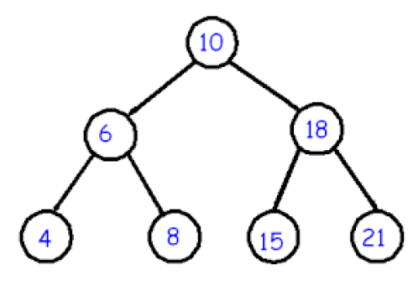Write a c program for this process tree.

Each node will print its name and PID but by not using printf().

**(10 marks)**

Write System calls for Shared Memory other than shmget **(10 marks)**



System call for named pipe is _____________________.

System call for unnamed pipe is ____________________.

System call for pushing your message in queue is ____________________.

Explain functions and their arguments:

msgrcv(msgid,&msg,sizeof(msg),1,0);

shmget(key, MAXSIZE, IPC_CREAT | 0666);

write(fd,buffer,sizeof(buffer));

**Bonus Question:**

Write anything which proves me you are a Linux User. Bonus marks depends on your creativity.